H1. Healthcare: generate and review a patient-intake component

Login with GitHub Copilot
Create a Prompt
- create a table stuture to manage Healthcare: generate and review a patient-intake component
- create a prompt for code app development using github copilot with above SharePoint lists and screens
Then Start the app creation using below prompt

Prompt
Build a complete Healthcare Patient Intake Management Application using:
Technology Stack:
- React + TypeScript
- Fluent UI v9
- Microsoft Graph API
- SharePoint Online Lists as backend
- Power Apps Code App architecture
- Power Automate for approvals
- Optional Power BI integration
- Responsive UI
- Accessibility (WCAG compliant)

Generate production-ready code, folder structure, services, interfaces, mock data, and reusable components.

==========================================
BUSINESS REQUIREMENT
==========================================

The system should allow healthcare staff to:

1. Register Patients
2. Capture Patient Intake Forms
3. Manage Insurance Information
4. Record Medical History
5. Record Allergies
6. Record Current Medications
7. Schedule Appointments
8. Review and Approve Intake Forms
9. View Dashboards and Statistics

==========================================
SHAREPOINT LISTS
==========================================

Patients

Columns:
- ID
- Title (MRN Number)
- First Name
- Last Name
- Gender
- Date of Birth
- Mobile Number
- Email
- Address
- City
- State
- Postal Code
- Emergency Contact Name
- Emergency Contact Number
- Status

------------------------------------------

Insurance Details

Columns:
- ID
- Title (Policy Number)
- Patient (Lookup to Patients)
- Provider Name
- Group Number
- Coverage Type
- Effective Date
- Expiry Date
- Verification Status

------------------------------------------

Patient Intake Forms

Columns:
- ID
- Title
- Patient (Lookup)
- Visit Reason
- Symptoms
- Preferred Language
- Weight
- Height
- Blood Type
- Intake Date
- Status
- Submitted By
- Submission Date

------------------------------------------

Medical History

Columns:
- ID
- Title (Condition Name)
- Patient (Lookup)
- Diagnosis Date
- Is Active
- Notes

------------------------------------------

Allergies

Columns:
- ID
- Title (Allergy Name)
- Patient (Lookup)
- Allergy Type
- Severity
- Reaction

------------------------------------------

Medications

Columns:
- ID
- Title (Medication Name)
- Patient (Lookup)
- Dosage
- Frequency
- Start Date
- End Date
- Prescribing Doctor

------------------------------------------

Appointments

Columns:
- ID
- Title
- Patient (Lookup)
- Appointment Date
- Doctor
- Appointment Type
- Status
- Notes

------------------------------------------

Intake Reviews

Columns:
- ID
- Title
- Intake Form (Lookup)
- Reviewer
- Review Date
- Review Status
- Comments

==========================================
APPLICATION SCREENS
==========================================

1. Dashboard

Show:
- Total Patients
- Today's Appointments
- Pending Reviews
- Active Insurance Plans
- Recent Patients
- Upcoming Appointments

Provide cards and charts.

------------------------------------------

2. Patient Management

Features:
- Create Patient
- Edit Patient
- View Patient
- Search Patient
- Filter Patient
- View Complete Profile

Display:
- Demographics
- Insurance
- Medical History
- Allergies
- Medications
- Appointments

------------------------------------------

3. Patient Intake Screen

Features:
- Multi-step wizard

Step 1:
Patient Information

Step 2:
Visit Details

Step 3:
Symptoms

Step 4:
Medical History

Step 5:
Allergies

Step 6:
Medications

Step 7:
Review & Submit

Validation:
- Required fields
- Date validation
- Numeric validation

------------------------------------------

4. Medical History Screen

Features:
- Add Condition
- Edit Condition
- Delete Condition
- View History

------------------------------------------

5. Allergy Management Screen

Features:
- Add Allergy
- Edit Allergy
- Delete Allergy
- Severity badge

------------------------------------------

6. Medication Management Screen

Features:
- Add Medication
- Update Medication
- Mark Completed

------------------------------------------

7. Appointment Screen

Features:
- Schedule Appointment
- Reschedule
- Cancel Appointment
- Calendar View
- Agenda View

------------------------------------------

8. Intake Review Screen

For Nurses and Doctors

Features:
- View Submitted Forms
- Approve
- Reject
- Add Comments
- Audit Trail

Status Values:
- Draft
- Submitted
- Under Review
- Approved
- Rejected

------------------------------------------

9. Admin Screen

Features:
- Manage Master Data
- Manage Doctors
- Manage Insurance Providers
- Audit Logs
- Application Settings

==========================================
PERMISSIONS
==========================================

Roles:

Receptionist
- Patient Registration
- Appointment Scheduling

Nurse
- Review Intake Forms
- Maintain Medical History

Doctor
- Approve Intake Forms
- View Patient Records

Admin
- Full Access

Implement role-based rendering.

==========================================
SHAREPOINT SERVICE LAYER
==========================================

Create:

/services
SharePointService.ts
PatientService.ts
IntakeService.ts
AppointmentService.ts
InsuranceService.ts

Capabilities:

- Get Items
- Create Item
- Update Item
- Delete Item
- Batch Operations
- Lookup Expansion
- Error Handling

==========================================
MODELS
==========================================

Generate TypeScript interfaces for all SharePoint lists.

Example:

IPatient
IInsurance
IPatientIntake
IMedicalHistory
IAllergy
IMedication
IAppointment
IIntakeReview

==========================================
STATE MANAGEMENT
==========================================

Use:
- React Context API
or
- Redux Toolkit

Include:
- Loading Status
- Error Handling
- Notifications

==========================================
UI REQUIREMENTS
==========================================

Use Fluent UI v9.

Provide:
- Data Grid
- Command Bar
- Dialogs
- Wizard Forms
- Tabs
- Cards
- Badges
- Dashboard Widgets

Theme:
- Healthcare Professional Theme
- White, Blue, Green

==========================================
REPORTING
==========================================

Create dashboard widgets for:

- Patients by Gender
- Patients by Age Group
- Appointments by Doctor
- Intake Status
- Top Symptoms
- Insurance Verification Status

==========================================
POWER AUTOMATE
==========================================

Create approval workflow design:

When Intake Form Status = Submitted

→ Nurse Review
→ Doctor Review
→ Approval/Rejection Notification
→ Update Intake Review List

==========================================
NON-FUNCTIONAL REQUIREMENTS
==========================================

- Responsive Design
- Accessibility Compliance
- Error Logging
- Audit Trail
- Retry Logic
- Optimized SharePoint Queries
- Pagination
- Search
- Sorting
- Export to Excel
- Secure Coding Practices

==========================================
DELIVERABLES
==========================================

Generate:

1. Complete folder structure
2. TypeScript interfaces
3. Fluent UI components
4. React pages
5. SharePoint service layer
6. Mock data
7. State management
8. Routing configuration
9. Approval workflow logic
10. Sample dashboard implementation
11. Deployment instructions
12. Unit test examples

Provide production-ready code with comments and best practices.

After App created run it
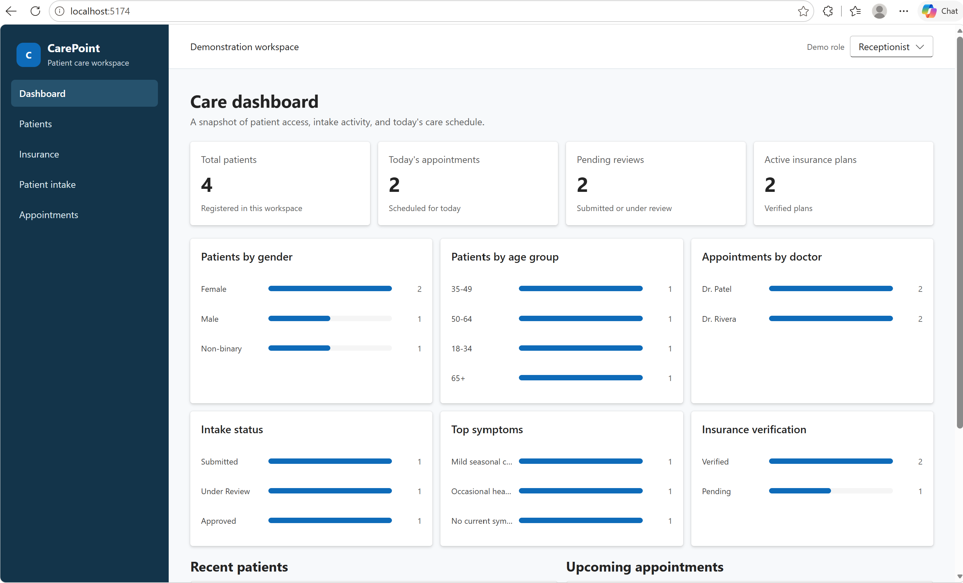

Create a SharePoint Site
https://jpower4mvp.sharepoint.com.mcas.ms/sites/CodeApp
Prompt - Create the SharePoint lists
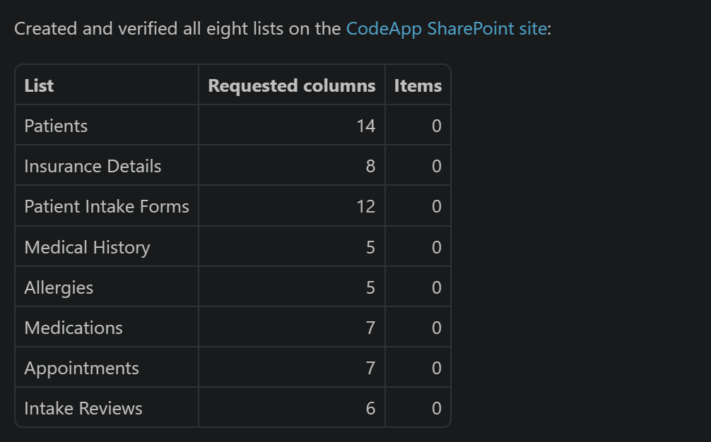

Prompt - Add 25 sample records each list
